การตรวจสอบและแก้ไขปัญหา
- เมื่อพบว่า server มีการตอบสนองช้าลง ซึ่งอาจจะเป็นได้จากการที่ RAM ของ Server ไม่พอ หรือมีการใช้งาน Memory ผิดปกติ สามารถเข้าไปตรวจสอบได้ที่ Grafana Dashboard
https://bma-dashboard.frappet.synology.me/d/fnX_0dPVk/docker-and-system-monitoring?orgId=1&refresh=5m
- เมื่อเข้ามาแล้วจะเจอหน้า dashboard ให้ไปดูในส่วนของ Memory Consume
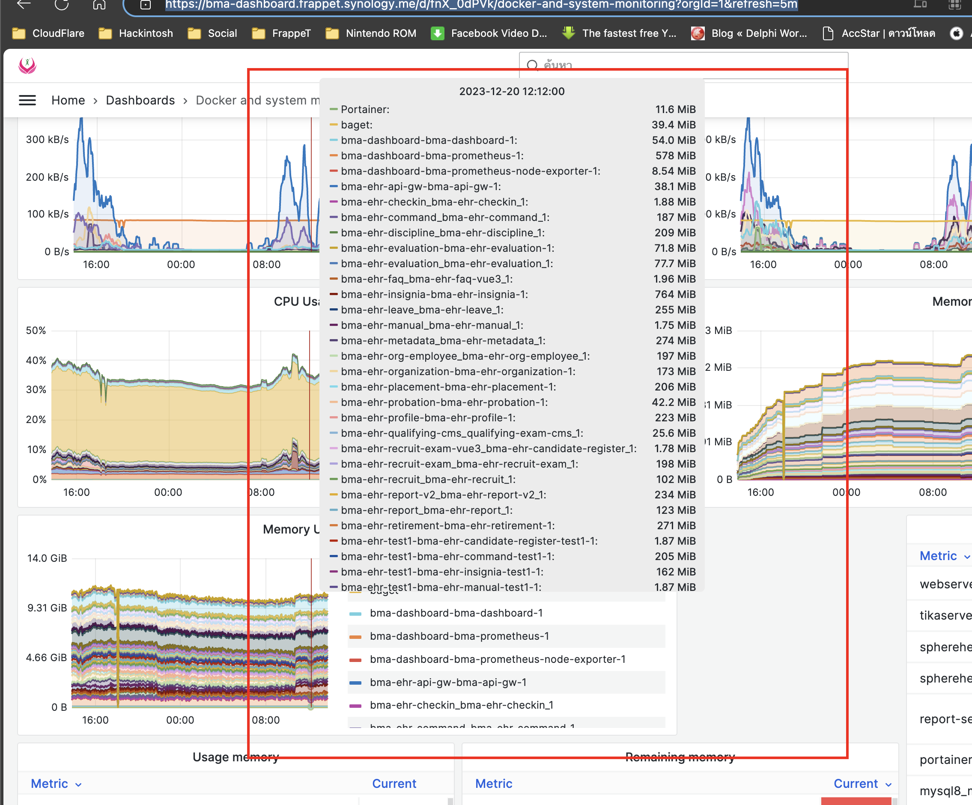
รูปภาพที่ 1 - 1 dashboard
- เมื่อพบว่ามี container ตัวใดที่มีการใช้ memory มากผิดปกติ เราจะเข้าไปทำการ stop continer หรือทำการ restart Container ใหม่ โดย ssh เข้าไปที่เครื่อง server
ssh frappet@frappet.com
- ทำการใส่ password หลังจากนั้นระบบจะ ssh ไปที่เครื่อง server
Processes: 619
Users logged in: 0
IPv4 address for br-0dd81f9616d2: 172.29.0.1
IPv4 address for br-10daaad45f51: 172.24.0.1
IPv4 address for br-17ffe0376048: 172.18.0.1
IPv4 address for br-3d380c3389b3: 192.168.16.1
IPv4 address for br-3f6401891fa7: 192.168.112.1
IPv4 address for br-740c2421e277: 192.168.160.1
IPv4 address for br-76113759e390: 172.22.0.1
IPv4 address for br-78a07fc3256e: 172.28.0.1
IPv4 address for br-8600ab24caeb: 192.168.128.1
IPv4 address for br-a00fbbce01ad: 172.30.0.1
IPv4 address for br-a5db1b42e4eb: 192.168.176.1
IPv4 address for br-b52d32a1a1dc: 192.168.64.1
IPv4 address for br-c2fb84774a1c: 172.26.0.1
IPv4 address for br-c5fcf4a9ca46: 172.31.0.1
IPv4 address for br-cae9831fbd37: 192.168.192.1
IPv4 address for br-f433b0574747: 192.168.32.1
IPv4 address for br-f634ce1ce094: 172.23.0.1
IPv4 address for docker0: 172.17.0.1
IPv4 address for ens160: 192.168.1.9
IPv6 address for ens160: 2405:9800:b523:275e:20c:29ff:fec6:41e
=> / is using 89.9% of 97.87GB
=> There are 10 zombie processes.
* Strictly confined Kubernetes makes edge and IoT secure. Learn how MicroK8s
just raised the bar for easy, resilient and secure K8s cluster deployment.
https://ubuntu.com/engage/secure-kubernetes-at-the-edge
* Introducing Expanded Security Maintenance for Applications.
Receive updates to over 25,000 software packages with your
Ubuntu Pro subscription. Free for personal use.
https://ubuntu.com/pro
Expanded Security Maintenance for Applications is not enabled.
77 updates can be applied immediately.
To see these additional updates run: apt list --upgradable
9 additional security updates can be applied with ESM Apps.
Learn more about enabling ESM Apps service at https://ubuntu.com/esm
New release '22.04.3 LTS' available.
Run 'do-release-upgrade' to upgrade to it.
Last login: Mon Dec 18 13:16:51 2023 from 1.47.195.64
frappet@dockerserver:~$
- ทำการ Change Directory ไปยัง folder ที่ติดตั้ง Docker
frappet@dockerserver:~$ cd docker
- หลังจากนั้นทำการลิสต์รายการ Container ที่ Run อยู่ เพื่อที่จะทำการ Stop หรือ Restart Container ที่ต้องการ โดยใช้คำสั่ง
frappet@dockerserver:~/docker$ docker ps
- ระบบจะแสดงรายชื่อ Container ที่ทำงานอยู่ขั้นมา ตามภาพ
CONTAINER ID IMAGE COMMAND CREATED STATUS PORTS NAMES
1b490cd596b3 docker.frappet.com/ehr/bma-ehr-discipline-service:latest "dotnet BMA.EHR.Disc…" 3 hours ago Up 3 hours 443/tcp, 0.0.0.0:4034->80/tcp, :::4034->80/tcp bma-ehr-discipline_bma-ehr-discipline_1
8e2136443c8f docker.frappet.com/ehr/bma-ehr-user:latest "/usr/local/bin/entr…" 4 hours ago Up 4 hours 0.0.0.0:6022->80/tcp, :::6022->80/tcp bma-ehr-user_bma-ehr-user_1
88a201c6ed87 docker.frappet.com/ehr/bma-ehr-app:latest "/usr/local/bin/entr…" 4 hours ago Up 4 hours 0.0.0.0:6021->80/tcp, :::6021->80/tcp bma-ehr_bma-ehr-vue3_1
4b5c2dfc73dd docker.frappet.com/ehr/bma-ehr-evaluation-service:latest "docker-entrypoint.s…" 16 hours ago Up 16 hours 0.0.0.0:4036->13001/tcp, :::4036->13001/tcp bma-ehr-evaluation_bma-ehr-evaluation_1
f2180d210ece docker.frappet.com/ehr/bma-ehr-leave-service:latest "dotnet BMA.EHR.Leav…" 28 hours ago Up 28 hours 443/tcp, 0.0.0.0:6031->80/tcp, :::6031->80/tcp bma-ehr-leave_bma-ehr-leave_1
9bcae7358913 docker.frappet.com/ehr/bma-ehr-insignia-service:latest "dotnet BMA.EHR.Insi…" 2 days ago Up 3 hours 443/tcp, 0.0.0.0:4031->80/tcp, :::4031->80/tcp bma-ehr-insignia-bma-ehr-insignia-1
8216f092003e docker.frappet.com/ehr/bma-ehr-retirement-service:latest "dotnet BMA.EHR.Reti…" 2 days ago Up 2 days 443/tcp, 0.0.0.0:4030->80/tcp, :::4030->80/tcp bma-ehr-retirement-bma-ehr-retirement-1
84e0af170318 docker.frappet.com/ehr/bma-ehr-placement-service:latest "dotnet BMA.EHR.Plac…" 2 days ago Up 2 days 443/tcp, 0.0.0.0:4032->80/tcp, :::4032->80/tcp bma-ehr-placement-bma-ehr-placement-1
abd638c4d347 docker.frappet.com/ehr/bma-ehr-faq:latest "/docker-entrypoint.…" 4 days ago Up 2 days 0.0.0.0:6025->80/tcp, :::6025->80/tcp bma-ehr-faq_bma-ehr-faq-vue3_1
4bcf444f2c90 docker.frappet.com/ehr/bma-ehr-profile-service:latest "dotnet BMA-EHR-Prof…" 6 days ago Up 2 days 443/tcp, 0.0.0.0:4027->80/tcp, :::4027->80/tcp bma-ehr-profile-bma-ehr-profile-1
2c824a54400b docker.frappet.com/ehr/bma-ehr-checkin:latest "/usr/local/bin/entr…" 6 days ago Up 2 days 0.0.0.0:6024->80/tcp, :::6024->80/tcp bma-ehr-checkin_bma-ehr-checkin_1
c48ec3e13ea5 ehr-report-api "dotnet eHR-Report-A…" 10 days ago Up 2 days 0.0.0.0:4430->443/tcp, :::4430->443/tcp, 0.0.0.0:81->5000/tcp, :::81->5000/tcp ehr-report-api
c9a970aff8a7 docker.frappet.com/ehr/bma-ehr-organization-service:latest "dotnet BMA.EHR.Orga…" 13 days ago Up 2 days 443/tcp, 0.0.0.0:4026->80/tcp, :::4026->80/tcp bma-ehr-organization-bma-ehr-organization-1
80403c502f6a docker.frappet.com/ehr/bma-ehr-recruit-exam-service:latest "dotnet BMA.EHR.Recu…" 4 weeks ago Up 2 days 443/tcp, 0.0.0.0:4069->80/tcp, :::4069->80/tcp bma-ehr-test1-bma-ehr-recruit-exam-test1-1
99da356ddea5 docker.frappet.com/ehr/bma-ehr-recruit-exam-service:latest "dotnet BMA.EHR.Recu…" 4 weeks ago Up 2 days 443/tcp, 0.0.0.0:4033->80/tcp, :::4033->80/tcp bma-ehr-recruit-exam_bma-ehr-recruit-exam_1
0ab8947355b6 3ad12046bf7c "/usr/local/bin/entr…" 4 weeks ago Up 2 days 80/tcp bma-ehr-test1-bma-ehr-test1-1
324cae12b336 docker.frappet.com/ehr/bma-ehr-manual:latest "/usr/local/bin/entr…" 4 weeks ago Up 2 days 80/tcp bma-ehr-test1-bma-ehr-manual-test1-1
d3c8b0d3383e 534aac270233 "/usr/local/bin/entr…" 4 weeks ago Up 2 days 80/tcp bma-ehr-test1-bma-ehr-user-test1-1
8ba1b37a622c docker.frappet.com/ehr/bma-ehr-org-employee-service:latest "dotnet BMA.EHR.Orga…" 4 weeks ago Up 2 days 80/tcp, 443/tcp bma-ehr-test1-bma-ehr-org-employee-test1-1
bb3555945d22 277e0ebc1631 "dotnet BMA.EHR.Reti…" 4 weeks ago Up 2 days 80/tcp, 443/tcp bma-ehr-test1-bma-ehr-retirement-test1-1
f4abc9d3d421 docker.frappet.com/ehr/bma-ehr-report-service:latest "dotnet BMA.EHR.Repo…" 4 weeks ago Up 2 days 80/tcp, 443/tcp bma-ehr-test1-bma-ehr-report-test1-1
73ae0a27a829 4cbb48b42190 "dotnet BMA.EHR.Insi…" 4 weeks ago Up 2 days 443/tcp, 0.0.0.0:5031->80/tcp, :::5031->80/tcp bma-ehr-test1-bma-ehr-insignia-test1-1
f0e5346e71c5 d65b54269209 "dotnet BMA-EHR-Prof…" 4 weeks ago Up 2 days 80/tcp, 443/tcp bma-ehr-test1-bma-ehr-profile-test1-1
a629aad58606 mongo:4.2.0 "docker-entrypoint.s…" 4 weeks ago Up 2 days 0.0.0.0:4062->27017/tcp, :::4062->27017/tcp bma-ehr-test1-bma-mongodb-test1-1
3a23d61be33b docker.frappet.com/ehr/bma-ehr-organization-service:latest "dotnet BMA.EHR.Orga…" 4 weeks ago Up 2 days 80/tcp, 443/tcp bma-ehr-test1-bma-ehr-organization-test1-1
4a6e110697a8 docker.frappet.com/demo/qualifying-exam-cms:latest "docker-entrypoint.s…" 4 weeks ago Up 2 days 80/tcp bma-ehr-test1-bma-ehr-qualifying-exam-cms-test1-1
86e94db01203 docker.frappet.com/ehr/bma-ehr-node-service:version-1.0.7 "docker-entrypoint.s…" 4 weeks ago Up 2 days 8080/tcp bma-ehr-test1-bma-ehr-probation-test1-1
e47ff4ea8266 docker.frappet.com/ehr/bma-ehr-report-v2-service:latest "dotnet BMA.EHR.Repo…" 4 weeks ago Up 2 days 80/tcp, 443/tcp bma-ehr-test1-bma-ehr-report-v2-test1-1
dd6c18083ebc docker.frappet.com/ehr/bma-ehr-command-service:latest "dotnet BMA.EHR.Comm…" 4 weeks ago Up 2 days 80/tcp, 443/tcp bma-ehr-test1-bma-ehr-command-test1-1
b268b267da1d mysql:8.0.17 "docker-entrypoint.s…" 4 weeks ago Up 20 hours 33060/tcp, 0.0.0.0:4061->3306/tcp, :::4061->3306/tcp bma-ehr-test1-bma-mysql-test1-1
856992fb6851 docker.frappet.com/ehr/bma-ehr-recruit-service:latest "dotnet BMA.EHR.Recr…" 4 weeks ago Up 2 days 80/tcp, 443/tcp bma-ehr-test1-bma-ehr-recruit-test1-1
35c36ed5b7c0 docker.frappet.com/ehr/bma-ehr-metadata-service:latest "dotnet BMA.EHR.Meta…" 4 weeks ago Up 2 days 443/tcp, 0.0.0.0:4065->80/tcp, :::4065->80/tcp bma-ehr-test1-bma-ehr-metadata-test1-1
23a6df9c1be5 7857451b76dc "dotnet BMA.EHR.Plac…" 4 weeks ago Up 2 days 80/tcp, 443/tcp bma-ehr-test1-bma-ehr-placement-test1-1
ef3721d59245 docker.frappet.com/ehr/bma-ehr-recruit-exam:latest "/usr/local/bin/entr…" 4 weeks ago Up 2 days 80/tcp bma-ehr-test1-bma-ehr-candidate-register-test1-1
1663ca346dde docker.frappet.com/ehr/bma-ehr-manual:latest "/usr/local/bin/entr…" 4 weeks ago Up 2 days 0.0.0.0:6023->80/tcp, :::6023->80/tcp bma-ehr-manual_bma-ehr-manual_1
4415bd986a99 docker.frappet.com/ehr/bma-ehr-report-v2-service:latest "dotnet BMA.EHR.Repo…" 5 weeks ago Up 2 days 443/tcp, 0.0.0.0:6029->80/tcp, :::6029->80/tcp bma-ehr-report-v2_bma-ehr-report-v2_1
90c1c4d15b2e docker.frappet.com/ehr/bma-ehr-recruit-exam:latest "/usr/local/bin/entr…" 5 weeks ago Up 2 days 0.0.0.0:4021->80/tcp, :::4021->80/tcp bma-ehr-recruit-exam-vue3_bma-ehr-candidate-register_1
2658a45bca14 docker.frappet.com/ehr/bma-ehr-report-service:latest "dotnet BMA.EHR.Repo…" 5 weeks ago Up 2 days 443/tcp, 0.0.0.0:5026->80/tcp, :::5026->80/tcp bma-ehr-report_bma-ehr-report_1
aad53f02bf58 docker.frappet.com/ehr/bma-ehr-command-service:latest "dotnet BMA.EHR.Comm…" 7 weeks ago Up 2 days 443/tcp, 0.0.0.0:6026->80/tcp, :::6026->80/tcp bma-ehr-command_bma-ehr-command_1
fff43fecaacb docker.frappet.com/ehr/bma-ehr-org-employee-service:latest "dotnet BMA.EHR.Orga…" 2 months ago Up 2 days 80/tcp, 443/tcp bma-ehr-org-employee_bma-ehr-org-employee_1
dd6d3d8bc546 docker.frappet.com/ehr/bma-ehr-node-service:version-1.0.7 "docker-entrypoint.s…" 2 months ago Up 2 days 8080/tcp bma-ehr-probation-bma-ehr-probation-1
ccefc50482a6 docker.frappet.com/demo/qualifying-exam-cms:latest "docker-entrypoint.s…" 2 months ago Up 2 days 0.0.0.0:4028->80/tcp, :::4028->80/tcp bma-ehr-qualifying-cms_qualifying-exam-cms_1
cc009e492421 docker.frappet.com/ehr/bma-ehr-recruit-service:latest "dotnet BMA.EHR.Recr…" 2 months ago Up 2 days 80/tcp, 443/tcp bma-ehr-recruit_bma-ehr-recruit_1
8b733df6a834 docker.frappet.com/demo/report-server:latest "docker-entrypoint.s…" 2 months ago Up 2 days 0.0.0.0:3090->80/tcp, :::3090->80/tcp report-server-report-server-1
864e845766ae bd57ddd1e93d "dotnet SphereHealth…" 2 months ago Restarting (139) 47 seconds ago spherehealth-prod-spherehealth-backend-prod-1
24745bd3cbde d3b506a2d4b9 "/usr/local/bin/entr…" 3 months ago Up 2 days 80/tcp spherehealth-prod-spherehealth-vue3-prod-1
acc0c1746f0f docker.frappet.com/ehr/bma-ehr-metadata-service:latest "dotnet BMA.EHR.Meta…" 3 months ago Up 2 days 443/tcp, 0.0.0.0:4025->80/tcp, :::4025->80/tcp bma-ehr-metadata_bma-ehr-metadata_1
f5f05cc90d11 quay.io/keycloak/keycloak:20.0.3 "/opt/keycloak/bin/k…" 4 months ago Up 2 days 8443/tcp, 0.0.0.0:9010->8080/tcp, :::9010->8080/tcp keycloak-test
fee432384ea7 postgres:15.1-alpine "docker-entrypoint.s…" 6 months ago Up 2 days 5432/tcp keycloak-identity-postgres-1
3c3ac01091e6 loicsharma/baget:0b46f0ec87216e1dc6839277712ee07c1c2b611a "dotnet BaGet.dll" 6 months ago Up 2 days 0.0.0.0:15556->80/tcp, :::15556->80/tcp baget
40f054ece24f prom/prometheus:latest "/bin/prometheus --c…" 6 months ago Up 2 days 9090/tcp bma-dashboard-bma-prometheus-1
e17adaf40f28 docker.frappet.com/demo/bma-dashboard:latest "/run.sh" 6 months ago Up 2 days 3000/tcp bma-dashboard-bma-dashboard-1
8d2e117e4306 google/cadvisor:latest "/usr/bin/cadvisor -…" 6 months ago Up 2 days 8080/tcp monitoring_cadvisor
a288c7d7b10c prom/node-exporter "/bin/node_exporter" 6 months ago Up 2 days 9100/tcp bma-dashboard-bma-prometheus-node-exporter-1
c4fea5e15f78 traefik:v2.10 "/entrypoint.sh trae…" 7 months ago Up 2 days 0.0.0.0:4020->80/tcp, :::4020->80/tcp bma-ehr-api-gw-bma-api-gw-1
9806b55da711 apache-php7 "docker-php-entrypoi…" 7 months ago Up 2 days 0.0.0.0:80->80/tcp, :::80->80/tcp, 0.0.0.0:443->443/tcp, :::443->443/tcp webserver
e7808259eab3 tika-server "/bin/sh -c 'java -j…" 7 months ago Up 2 days 0.0.0.0:9998->9998/tcp, :::9998->9998/tcp tikaserver
9af0aec7f9ba mysql:8.0.17 "docker-entrypoint.s…" 7 months ago Up 2 days 0.0.0.0:3306->3306/tcp, :::3306->3306/tcp, 33060/tcp mysql
6859572c42b5 mongo:4.2.0 "docker-entrypoint.s…" 7 months ago Up 2 days 0.0.0.0:27017->27017/tcp, :::27017->27017/tcp mongo
afe584fe1269 mysql/mysql-server:8.0 "/entrypoint.sh --de…" 18 months ago Up 2 days (healthy) 33060-33061/tcp, 0.0.0.0:3311->3306/tcp, :::3311->3306/tcp mysql8_mysql_1
c2333a34ef69 mariadb:10.7.3 "docker-entrypoint.s…" 21 months ago Up 2 days 0.0.0.0:3310->3306/tcp, :::3310->3306/tcp mariadb_mysql_1
f5a0c9ae2498 phpmyadmin:latest "/docker-entrypoint.…" 23 months ago Up 2 days 80/tcp docker-x64-test_app.phpmyadmin_1
c20d70716107 mysql/mysql-server:8.0.23 "/entrypoint.sh --de…" 23 months ago Up 2 days (healthy) 33060-33061/tcp, 0.0.0.0:3308->3306/tcp, :::3308->3306/tcp docker-x64-test_app.mysql_1
b04141fe65d3 portainer/portainer-ce:latest "/portainer -H unix:…" 2 years ago Up 2 days 0.0.0.0:9004->8000/tcp, :::9004->8000/tcp, 0.0.0.0:9005->9000/tcp, :::9005->9000/tcp portainer_portainer_1
eb37e5951258 portainer/portainer "/portainer" 4 years ago Up 2 days 0.0.0.0:8000->8000/tcp, :::8000->8000/tcp, 0.0.0.0:9000->9000/tcp, :::9000->9000/tcp Portainer
frappet@dockerserver:~/docker$
- ทำการ Stop Container ที่ต้องการ โดยใช้คำสั่ง
frappet@dockerserver:~/docker$ docker stop <<container_name>>
- หลังจากนั้นทำการ Start Container ที่ต้องการขึ้นมาอีกครั้ง โดยการใช้คำสั่ง
frappet@dockerserver:~/docker$ docker start <<container_name>>

